Email
We’ve put together some best practices about storage and management of sequencing data. The resource is motivated by the CZ ID transition to UCSF. An important note is that the new SeqToID platform will not store raw sequencing data (FASTQs). This represents a significant departure from the current workflow, as the raw sequencing data will not be retrievable from the SeqToID pipeline's cloud environment after upload.

We recommend treating external storage of raw FASTQ files as a mandatory first step in any sequencing project and we would like to recommend the following practices. These tips also apply generally regardless of what platform you generate or analyze your sequencing data.

Sequencing Data Management Best Practices
This document is meant to provide some relevant considerations around data management and organization, however it is not intended as an exhaustive list of best practices. We recommend supplementing with additional resources.

Key takeaways
- The 3-2-1 rule: Your foundation for long-term storage: 3 copies of your data, on 2 media types, with 1 offsite or in the cloud.
- Keep your own raw data: never let short-term storage (sequencer, BaseSpace, scratch) be the only copy.
- Verify every transfer with a checksum or read count, not just file size.
- Name files and projects consistently (e.g. lead with date + project ID).

Preparing a Sequencing Data Storage System
We recommend keeping your own copies of all of your raw sequencing data files.

Data Handling - Best practices
- Short-term storage
  - Examples: workstation, sequencer computer, Basespace, HPC scratch
  - Short-term storage is typically limited and not backed up; do not store anything irreplaceable here; move to permanent storage location as soon as possible
  - Compressed files (fastq.gz vs fastq) can help save storage space
- Long-term storage (archival)
  - Examples: HPC archive, cloud archive, public repositories
  - Follow the 3-2-1 backup rule: 3 copies of data, on 2 different media types, with 1 offsite or in the cloud
  - It is ideal to have your sequencer connected directly to one of your long-term storages
  - Submit raw data to public repositories: raw reads may be submitted to NCBI SRA upon publication. This is required by many journals and funding bodies
  - Document the archive: maintain a spreadsheet/database of what is archived, where, and how to retrieve it. Include sample metadata, project name, and date archived.
  - Test restores periodically: archived data is useless if it can't be restored. Schedule an annual test retrieval
- Cleaning up space
  - Establish an SOP for cleaning up space
    - Identify storage limits and available space requirements for each storage type, especially short-term storage
    - Ensure initial data storage locations (sequencer local, Basespace, etc) will always have enough available space for the next sequencing run
    - Create a transfer and archival / deletion plan for each storage type
    - Train all team members on the SOP
File Naming and Data Integrity
- Maintain standardized file naming conventions (see suggestions below)
- Verify all transfers, copies, and downloads (Data Integrity)
  - MD5sum, counting reads/lines, comparing _R01 and _R02 fastq lengths (not just size), or other mechanism for confirming file integrity
- Capture and organize all relevant metadata
- Raw fastq files should be set to read-only after transfer/archival (e.g., chmod 444) so they can never be accidentally overwritten.
Other considerations
- Security and Access
- Metadata and Documentation

Data storage - Hardware options
Ideally we recommend working with your IT team to select and set up hardware that works for your needs.

Some notes from Biohub HPC/IT (not meant to be prescriptive, but outlines a few options):

Workstations
- For PCs, we recommend getting something like a Dell workstation. These can be customized and ordered directly from their website
- https://www.dell.com/en-us/shop/desktop-computers/scr/desktops/appref=dell-pro-max-product-line
  - This config has 2 TB SSD storage, a decent CPU with 14 cores, 1GbE Ethernet network card, and 32GB memory (you can add more memory in the future by adding another 32GB card).
  - Windows 11 comes included along with 36 months of Dell's support and warranty (which can be extended later). For an additional +$375.43 you can add a Nvidia A1000 8GB GPU (this is pretty standard these days).
- Mac mini or Mac studio are also options.
- The desktop PC / Mac workstations can have multiple TBs of internal storage too.

Long-term storage
- Recommended: for separate long term storage besides portable hard drives, the synology NAS tower storage server can be bought small (with only a few bays) and scaled up over time. These storage servers are pretty much turn-key solutions and can connect over 1/10GbE connections.
- External hard drives are not reliable long-term storage. They may be for individual use or secondary copies only, but failure rates are higher and they are not suitable as a primary storage solution.
- Cloud backup archive: be careful of costs
  - !! AWS might appear to require less maintenance, but it is very high cost. Make sure to have established rules, best practices, and glacier storage protocols. It is extremely easy to accidentally rack up costs without noticing. Do not use AWS without someone who has AWS admin experience
  - If you plan to use AWS for backup, !! only use it for glacier storage, not active storage
Support
- Technical support for setup of intermediate and long-term storage solutions and development of data handling SOPs will be necessary when onboarding these equipment
- Access to as-needed troubleshooting support will likely be necessary for sustainable data storage solutions

Project Organization

Example Project Structure
- Each project is given a project ID
- For example, RR001, RR002, RR003
- The projects are all recorded in a directory
  - Example project directory
  - 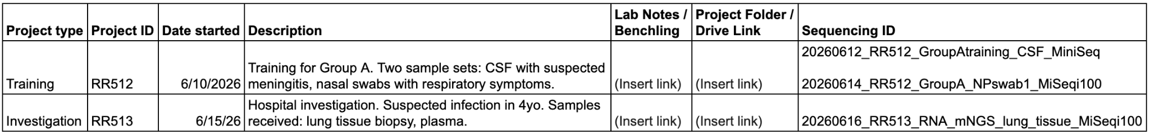
- A folder is created for each project

Standardized Naming Scheme - sequencing runs
- Each run shall have a consistent run name structure
- We suggest that all files and runs include at minimum date and project ID in their name
- One option:
  - YYYYMMDD_ProjectID_Run ID_short description_UserInitials
  - Example: 20250328_RR228_iSeqRun1_DENVamplicon_GP
- Maintain a sequencing log to record runs
  - Example run log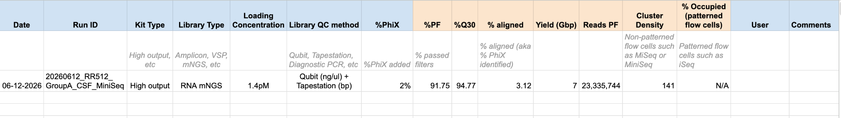
- Additional guidelines
  - No spaces or special characters in filenames. Use underscores or hyphens only.
  - Immutable raw data. Raw FASTQ files should never be edited or overwritten. Store originals in a read-only directory.
  - Consistent directory structure. e.g., project/raw/project_processed/ project_results/ project_docs/

Putting it all together: Example workflow for handling sequencing data
- Complete the run
  - Ideally run connected to Basespace* for temporary storage
*Requires internet connection; temporary local run storage is also okay
- After the run completes, transfer the entire run folder to a minimum of two locations. This can be done manually or configured for automatic backup transfer
  - Short-term storage (workstation or HPC scratch/working space)
  - Long-term storage
    - Examples: HPC archive, cloud archive, public repositories
    - Follow the 3-2-1 backup rule: 3 copies of data, on 2 different media types, with 1 offsite or in the cloud
- Verify transfer
  - MD5sum, counting reads/lines, comparing _R01 and _R02 fastq lengths (not just size), or other mechanism for confirming file integrity
- Storage cleaning
It is critical to have an SOP for cleaning your temporary storage locations (immediately after a run or periodically such as weekly/monthly) in order to ensure there is always free space for future runs
  - Sequencer computer
  - Basespace
  - Workstation / short-term storage
Always have 300+GB available on the SSD where you are writing runs (especially relevant for ONT)

Retrieving data from CZ ID
If there are data on CZ ID that you don’t have a copy of locally, here are some resources about how to retrieve that data.
- Initiate a Bulk Download
  - Tip: sometimes you may need to select fewer samples (50 or less) at a time for the download to be successful
- Download Via the Command Line
- Verify FASTQ File Downloads

